Prep:
-7 pieces of paper for each student (which I will call cards from here on). You can decide on what size you would like to use depending on the amount of time your class has to spend on the project. I have used 9x12, 4x6, and 2.5x4.

- Construction paper accordion book. Cut the construction paper so that there is a ½ inch boarder around each edge of each card plus an additional ½ on one side to connect the border paper together.

-Have students start thinking about what they can bring from home for their texture card (foil, string, plastic wrap, clean candy bar wrappers, etc.

1. Teacher will lecture over the Elements of Art (15-30 mis.)

2.) Students will decide and draw an image to use for their book.
They need to think about what that image would look like if you only saw an outline. Ex. if you did an outline of a basketball, would your viewer know it was a basketball, but if you drew the outline of an elephant, your viewer would definitely know what it is. Try to avoid thin images such as swords, snakes, worms, etc. (45 mins).

3.) Take your final drawing of the chosen item and trace only the outline onto each of the 7 pieces of drawing paper (cards). After tracing on their first card students will trace the image on the second card as a reflection of the first card. Each traced image (1 per piece of paper/card) will be a reflection of the previous paper (alternating). (45 mins)

4. Students will begin designing their Line card. Each student must choose and practice 1 straight line pattern and 1 curvy line pattern. They need to think about how they can make each design contrast one another other than the fact that one is curvy and one straight (ex: on is done with thin lines and the other is done with thick). When they have completed their practice, they will decide which pattern they want inside of their traced object on their first card (the second pattern will go on the outside). Students will draw their patterns where they have chosen and then color/trace each line with a black marker. I have my students use a black marker to trace over their outline, so it stands out. I have them complete this card in black and white only. (45 mins x 1-4)

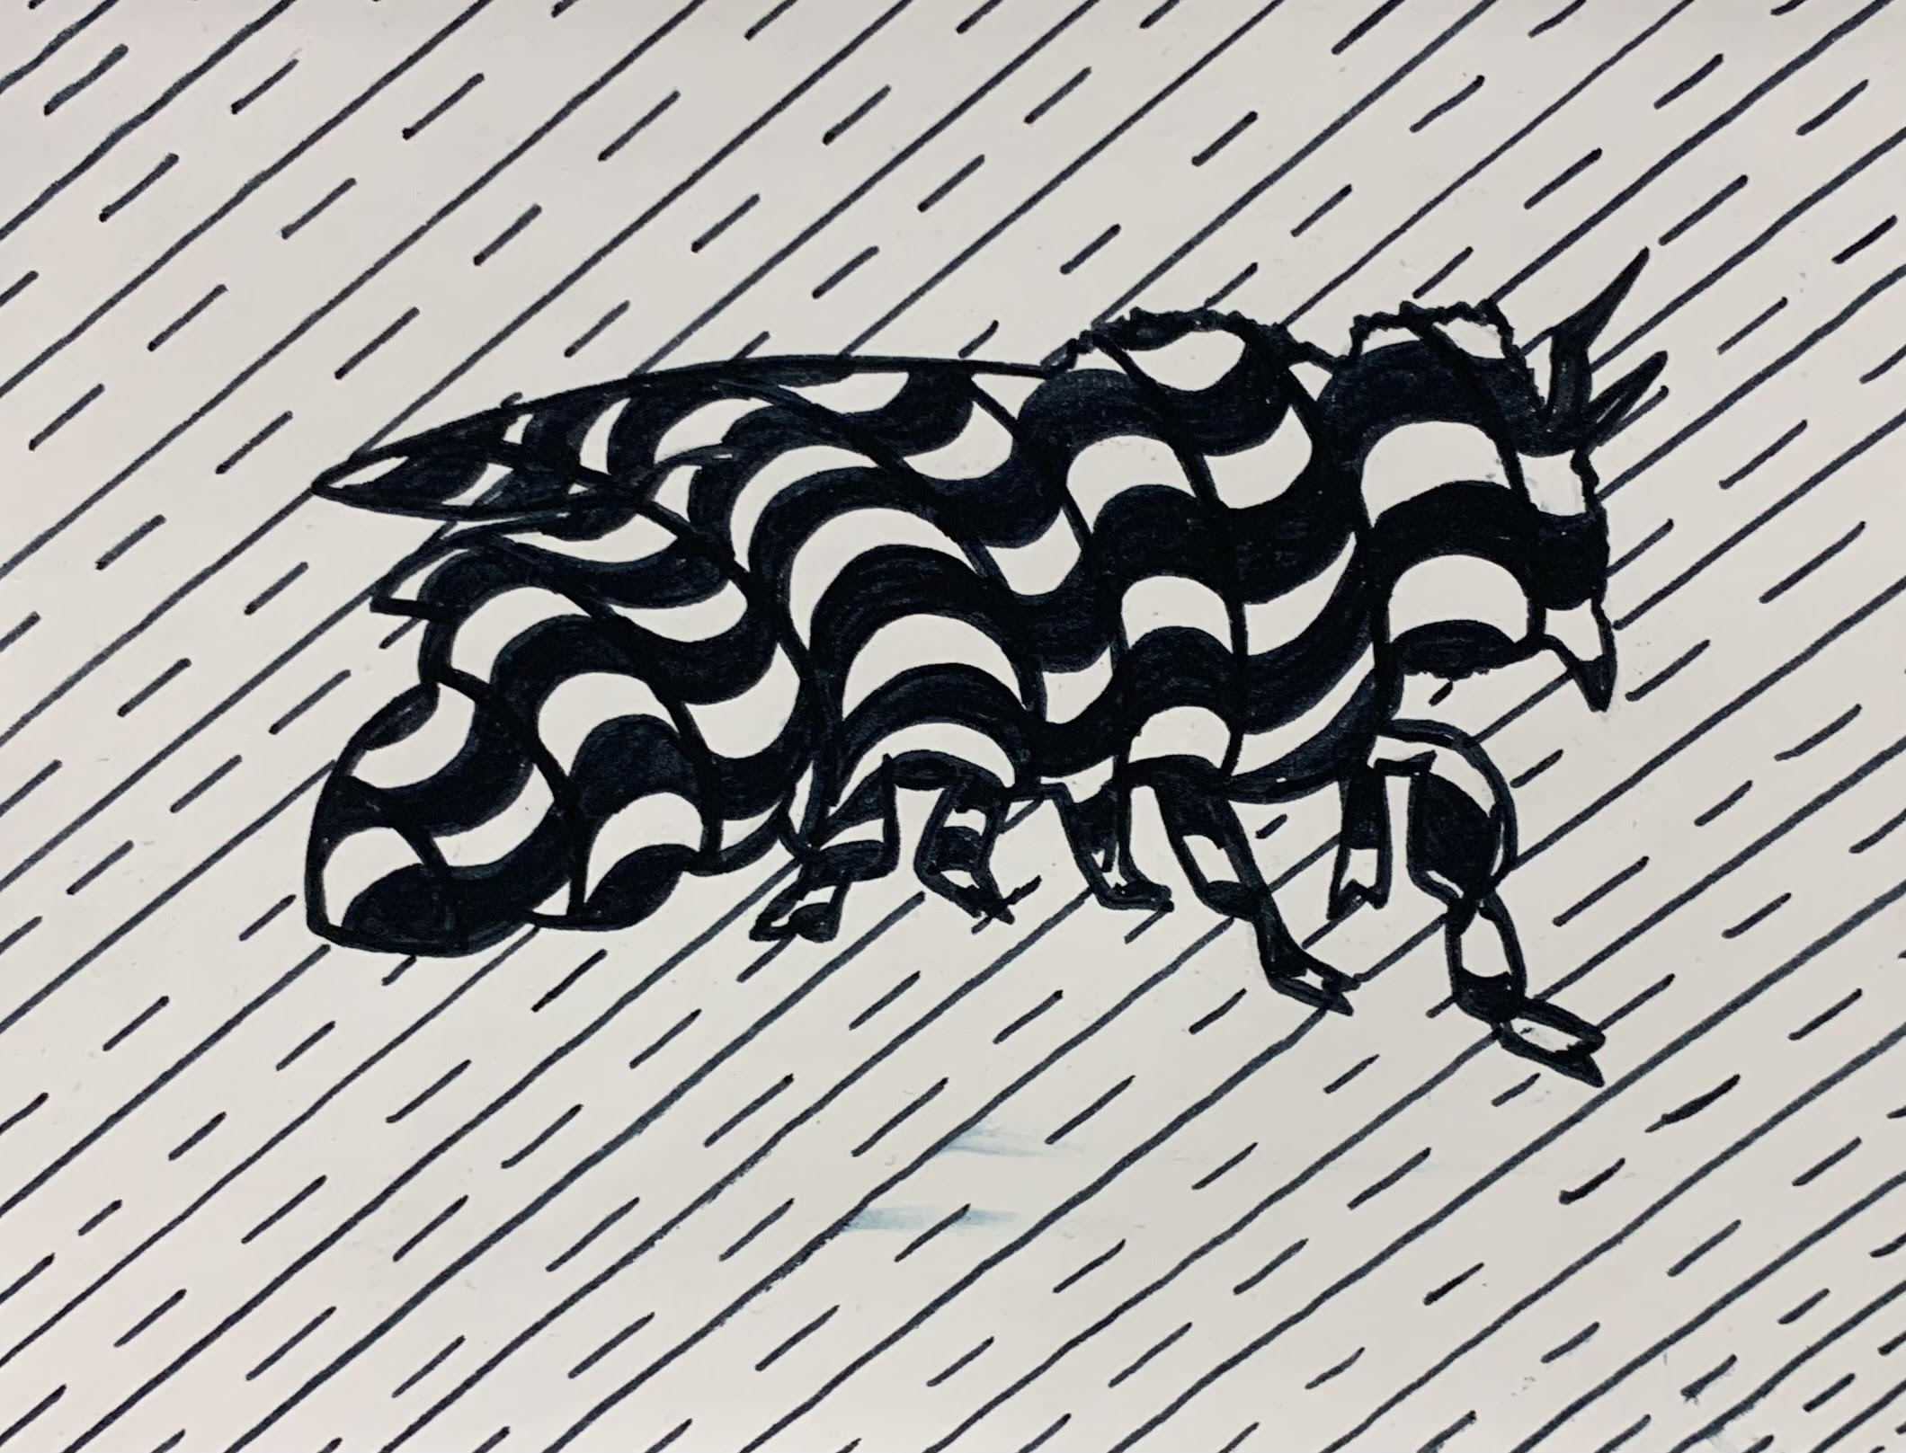

5. Students will begin designing their Shape card. Each student will use a variety of shapes to fill their outlined object in with. I have my students start with the largest shapes they can get that fit their space without touching the outline. Next, students will fit smaller shapes into the smaller spaces filling in any gaps. Students can then choose a pattern (using shapes) to fill in the background. Students can then choose what color they would like to color in each shape (I have mine find different color palettes they like) for each the inside and outside spaces. I have my students use a black colored pencil to trace over their outline, so it stands out. We use colored pencils on this one. (45 mins x 1-4)
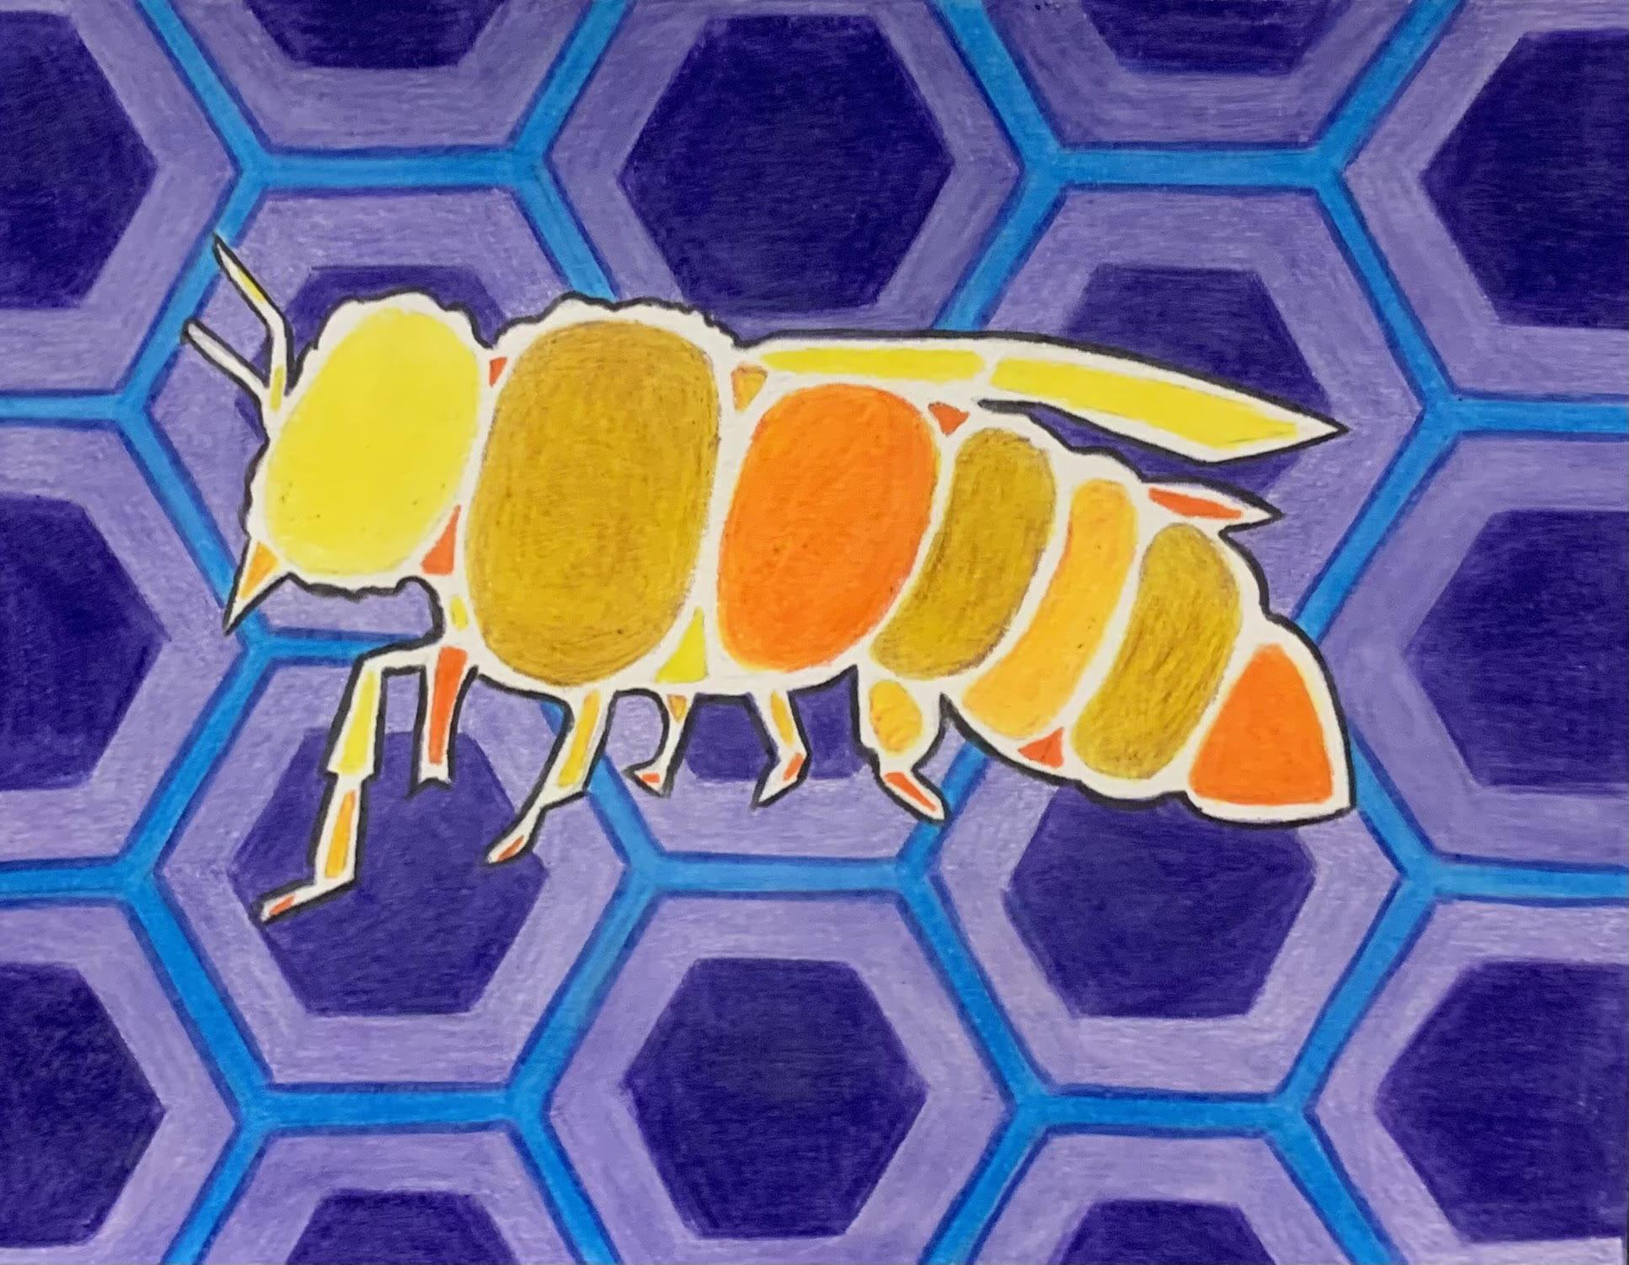

6. Students will begin designing their Space card. This is the card that I have my students create a more realistic representation of their object. Students must create a background, midground, and foreground for their object, some items must overlap, and this is where we should see the detail of their chosen object (not just the outline). We use colored pencils on this one. I have my students use a black colored pencil to trace over their outline, so it stands out. (45 mins x 1-4)

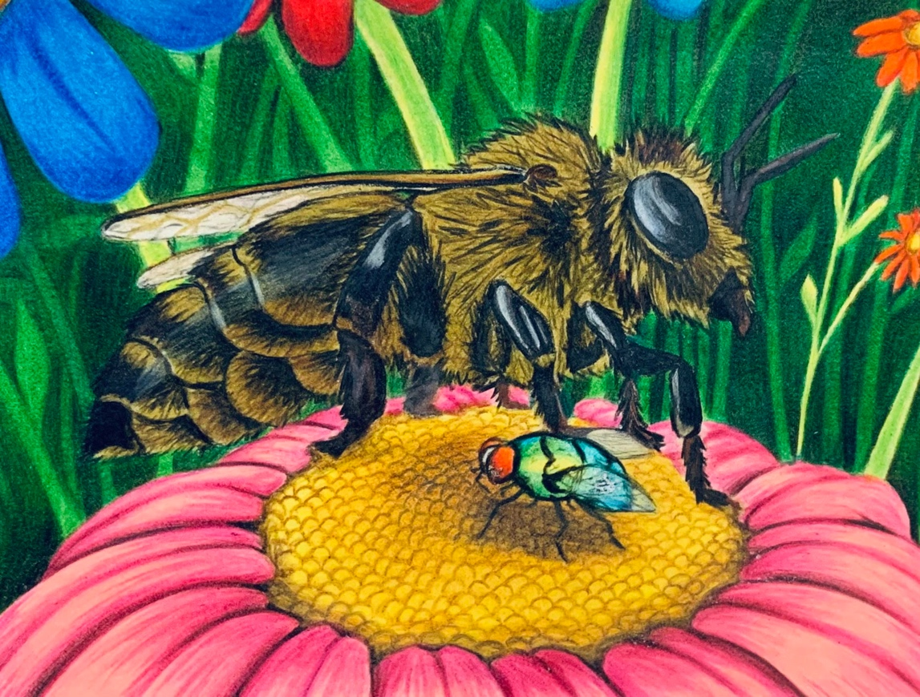

7. Students will begin designing their Color card. After reviewing the color wheel and color schemes, students will choose one color scheme for the inside of the object and one for the outside. We use colored pencils for this card. I have my students use a black colored pencil to trace over their outline, so it stands out. (45 mins x 1-4)

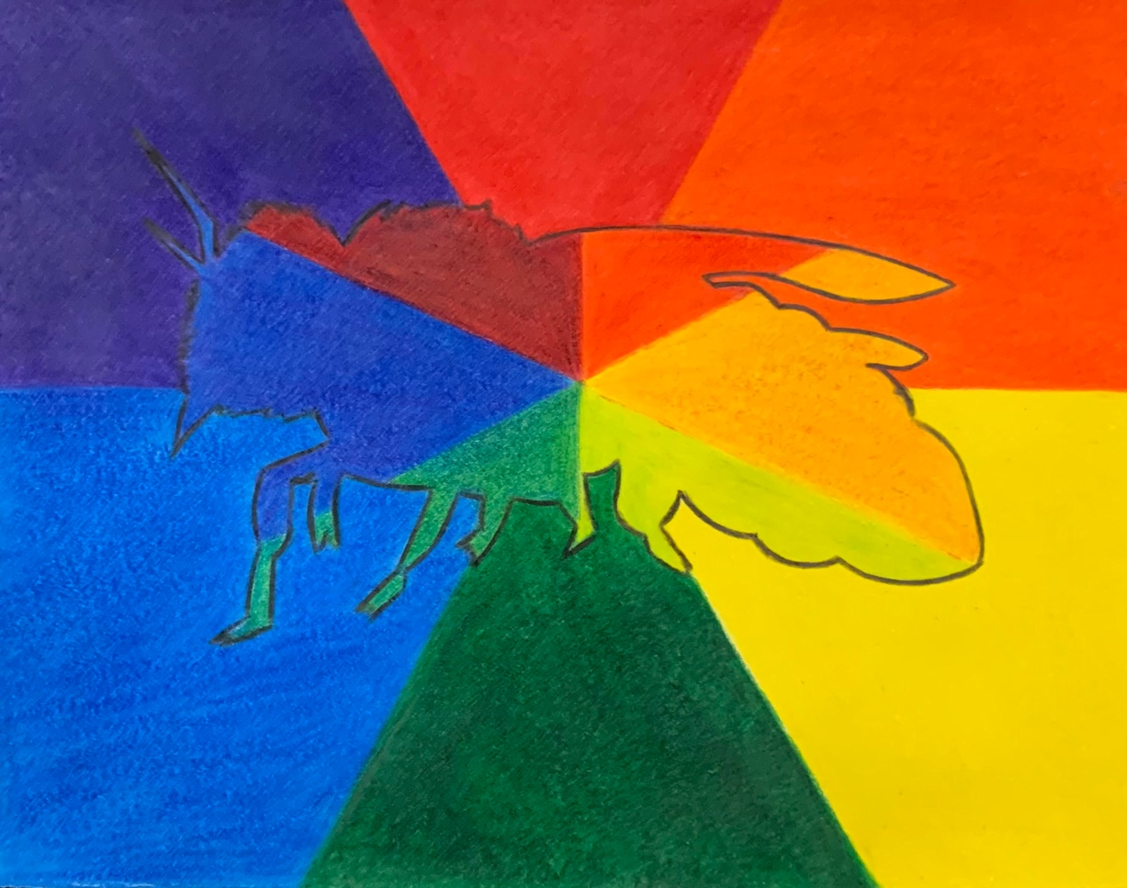

8. Students will begin designing their Texture card. Students will use a variety of materials provided by the teacher and themselves to create a collage of textures for this card. All items will be glued with Elmer’s glue. If possible, I have my students use a black colored pencil to trace over their outline, so it stands out. (45 mins x 1-4)

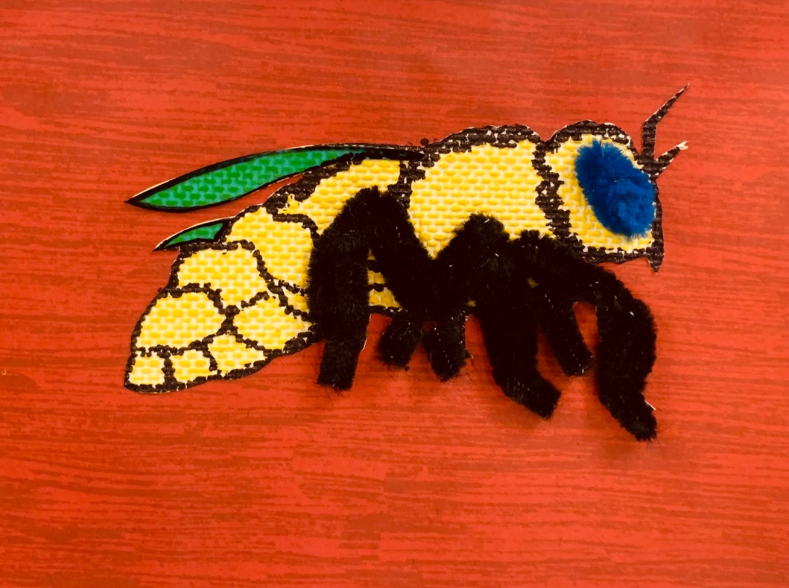

9. Students will begin designing their Value card. Students will use 7-10 intersecting lines to break up the background. Each line must touch 2 different sides of the card and cannot form a simple pattern (stripes, checkerboard, etc.). While drawing each line, students must use a ruler and stop drawing their line once they have hit the outline of their object (they will continue to the other side, no lines should go through the inside of the outline of the object). Students will do one large, continuous value scale on the inside of the object and each of the shapes that have been created in the background must have their own value scale as well. I try to have my students avoid putting 2 of the same values side by side if they can (dark next to dark, medium next to medium, or white next to white). We used graphite pencils for this. I have my students use a pencil to trace over their outline and each straight line in the background, so they a crisp, clean lines and the outline stands out. (45 mins x 1-4)

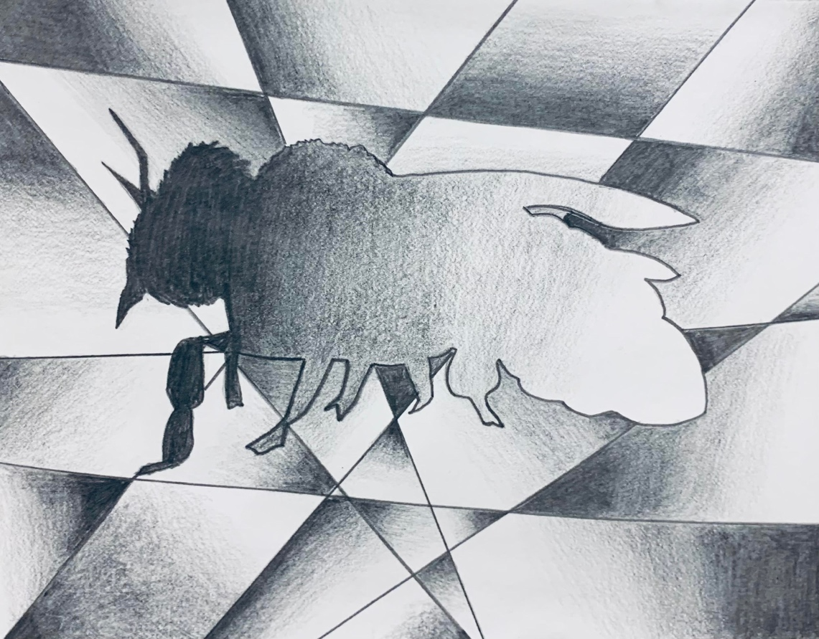

10. Students will begin designing their Form card. This card will be completed very similar to the shape card, but students need to use simple forms vs. simple shapes. Each student will use a variety of simple forms to fill their outlined object in with. I have my students start with the largest form they can get that fit their space without touching the outline. Next, students will fit smaller forms into the smaller spaces filling in any gaps. Students can then choose to fill the background in with a single color. Students can then choose what color they would like to color in each form. Students will have to use some shading techniques or variations of colors to make the forms look 3d. I have my students use a black colored pencil to trace over their outline, so it stands out. We use colored pencils on this one. (45 mins x 1-4)

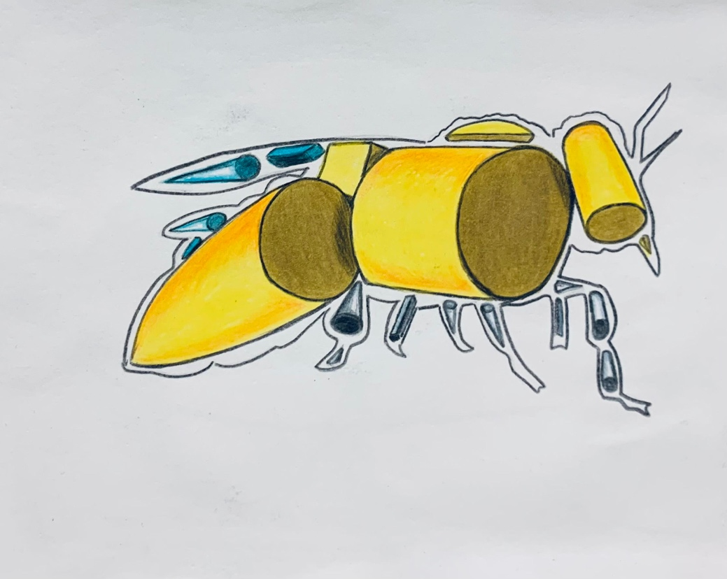

11. Each student will glue each of their cards to the provided construction paper and then glue and/or fold the construction paper into an accordion. (45 mins x 1-2)

